* 1. **Configuration**
     1. ***Set user name and email***
* git config --global user.name usernamehere
* git config –-global user.email useremailhere
  + 1. ***Get user name and email***
* git config –-global user.name
* git config –-global user.email
  + 1. ***Open Visual studio code***
* code .

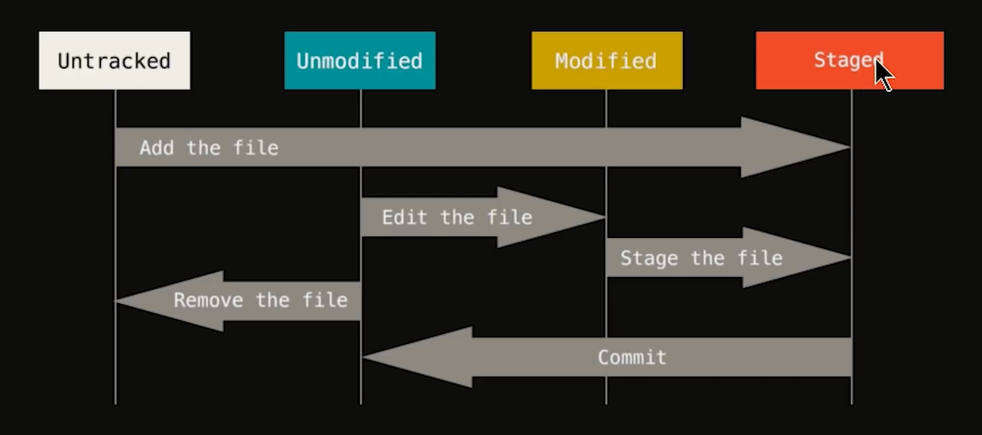

* 1. **Git Commands**
     1. ***Start git empty repository***
* git init
  + 1. ***Get status of files***
* git status
  + 1. ***Add files to staging area. (green color represents staged file)***
* git add filename
* git add -A *[ Add all files to staging area]*
  + 1. ***Git Initial commit***
* Git commit

***Note - [ after initial commit vim editor opens up then to type something as commit comment press “I” then type your comment example: “Initial Commit” then press “escape” key then type “:wq” then it will exit from vim editor ]***

* + 1. ***Git Commit [Without dealing with VM editor]***
* git commit -m “commit comment here” *[Make sure to write proper commit comment] [All files will get commit]*
  + 1. ***create empty files***
* touch filename
  + 1. **clear git bash**
* clear
  + 1. ***Match single working file to the last commit***
* git checkout filename
  + 1. ***Match all working files to the last commit***
* git checkout -f
  + 1. ***Get all commits information***
* git log
  + 1. ***Get filtered commits information***
* git log -p –[number] *[ change the number with value of which you want to see last commits]*

***Note - [Make sure to press “q” after checking commits to exit]***

* + 1. ***compare working directory with staging area***
* git diff
  + 1. ***compare staging area with last commit***
* git diff -staged
  + 1. ***Directly commit without staging***
* git commit -a -m “Skipped staging area and fixed <”

*[ add proper comment in double quotes]*

* + 1. ***Remove file from staged area means keep it on hard disk but untracked***
* git rm –cached filename *[Make sure to include filename]*
  + 1. ***Remove file from Hard disk [ File may be committed with git]***
* git rm filename *[Make sure to include filename]*
  + 1. ***Git Short status [Summarized status]***
* git status -s

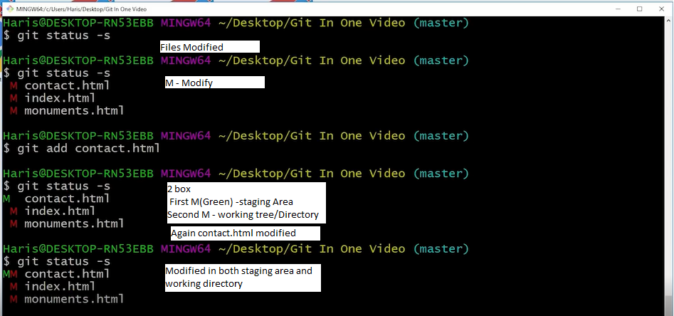

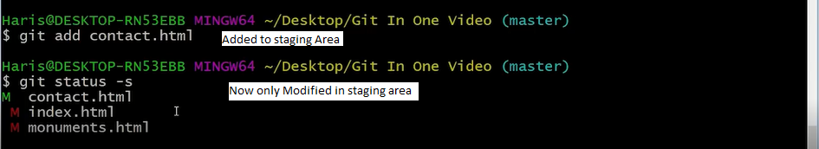

***Note - [Here in git short status command you will get output like above.***

***In Summarized status/short status command you will see “M” in front of file names. There you can see two boxes where first Green Box show staging area and second box shows working directory.]***

* + 1. ***Creating gitignore file. [only use git bash to create it]***
* touch .gitignore

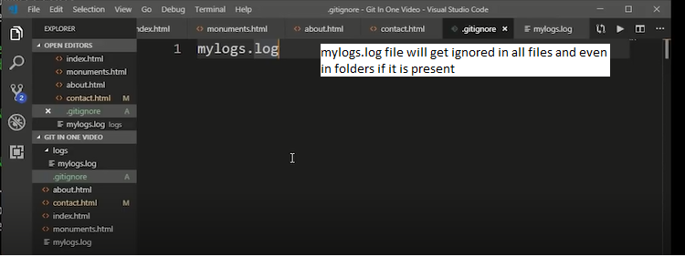

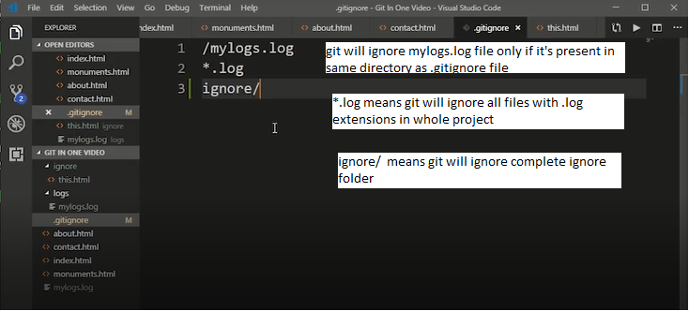

***Note - [This file will ignore all the files and folders which are included in this .gitignore file]***

* + 1. ***Create Git Branch***
* git branch branchname

*[ add branchname in command]*

* + 1. ***List out all Branches***
* git branch *[ The branch with * and color green is the current one on which you are making changes]*
  + 1. ***Switch Git Branch***
* git checkout branchname *[Make sure to include branchname]*
  + 1. ***Merge Git Branches***
* git checkout master

*[ Make sure to switch in master branch first you want to merge with master]*

* git merge branchname

*[ add branchname in command]*

* + 1. ***Create new git branch and switch to it at the same time in one command***
* git checkout -b branchname *[Make sure to include new branch name]*
  + 1. ***Connect Remote and local git repository***
* git remote add origin your_url_address

*[ In the above code, The 'origin' is the remote name, and the remote URL is your_url_address]*

* git push -u origin branchname ***[ Push to remote server]***

*[ add branchname in command]*

* + 1. ***Git pull request***
* git pull remote_name branch_name *[Make sure to add remote_name like origin and branch_name in command]*